Ear Acupressure for Anxiety and Sleep using Traditional Chinese Medicine
By Edythe Vickers ND, LAc

Ear acupuncture/acupressure is a system that can be used to bring balance to the body. There is a map of our entire body in the ear, and by stimulating certain points we can feel the effects of the release of endorphins (calming and soothing, centering and decreased pain).
If I had to pick 5 points to help in this time of great stress and anxiety, they would be as follows:

- Shen Men (Neurogate): In the triangular fossa, 1/3 of the way, between the apex of the triangular fossa, towards the helix. Shen Men is along the superior ridge of the fossa, in the upper half of the triangular fossa. Uses, anti-anxiety, sedative, analgesic, anti-allergies.
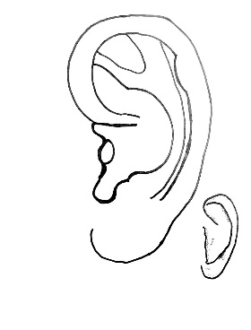
- Heart: In the lowest depression in the inferior concha. Indications for use include Heart issues, blood pressure issues, and mental disorders. This is a good point for strengthening the heart and calming the spirit.
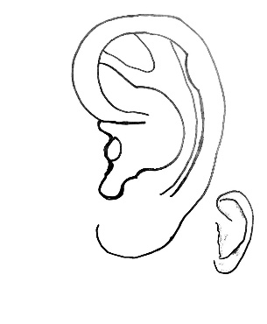
- Adrenal: At the prominence on the inferior part of the tragus. ¾ the distance from the top of the tragus to the bottom. Indications for use include regulation of cortisol and adrenalin. Also, for inflammation, allergies, shock, asthma and chronic diseases.
- Subcortex: On the anterior side of the inner wall of the antitragus, ½ way down the back side of the wall. Regulates excitation and inhibition of the cerebral cortex. Indications for use include insomnia, fatigue, neuropsychiatric problems, inflammation, excessive sweating, and pain.
- Brain: on the high point of the antitragus. Indications for use include excitation and inhibition of the brain. Used for any diseases of the nervous system, digestive system, urogenital system, or endocrine system.
Ear seeds or pellets consist of small black seeds from the vaccaria plant or small metal beads or ceramic pellets that are secured on the ear with a piece of adhesive tape over specific acupressure points. The continuous mild pressure they exert is amplified by stimulating the seed or pellet with a few seconds of fingertip massage every few hours. Ear seeds are non-invasive and do not puncture the skin. You can make these pellets at home with a dried bean and tape. Just take the dries bean or lentil and cover with a small piece of tape and apply to the point in your ear. The pressure of the tape allows the point to be stimulated. Keep on for 1-3 days.
You could also buy online vaccaria seeds or metal ears seeds. Look on amzon.com
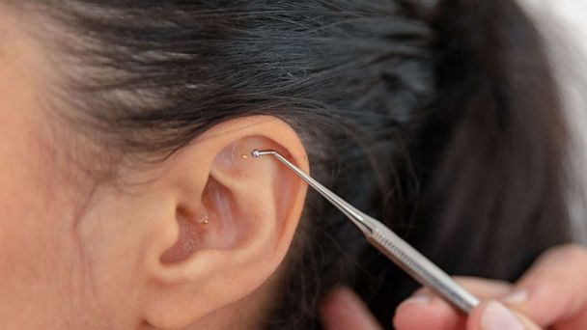
Here is a seed being placed on Shen Men, there is also one on Stomach.
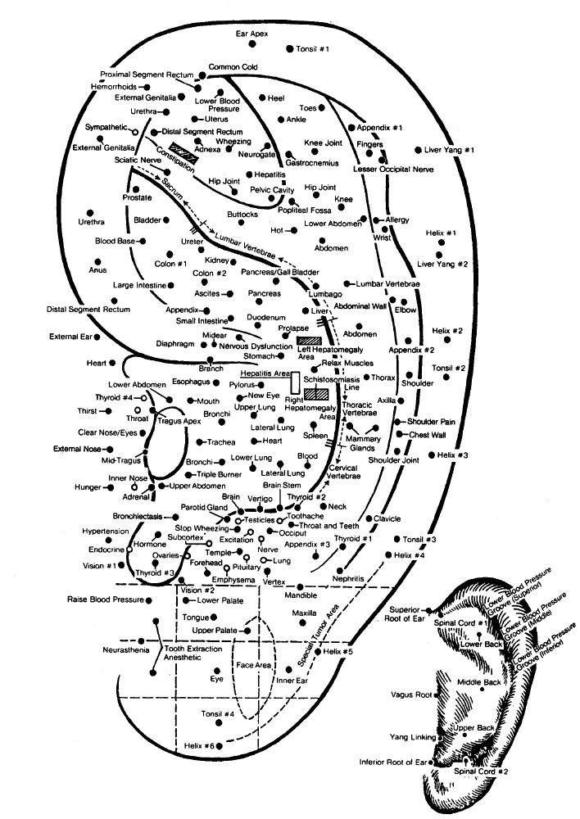
Some body pressure points that are also helpful during this time. You can place a bean over these points as well.
Heart 7 which is used for stress and worry, also poor sleep
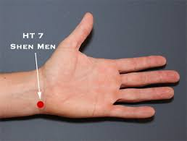

Pericardium 6: best known for nausea and vomiting, but also opens the chest and calms fright.
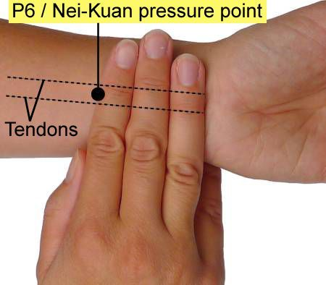

Kidney 1: best known for its calming and centering principles. It is also a good point for headaches
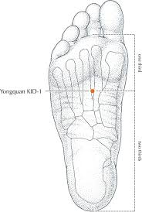

Stomach 36: aids digestive disturbances, and it great for calming and centering the body.
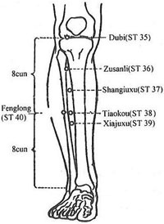
Governing Vessel 20: helps to regulate your energy, to sharpen your mind and aid concentration
